Nama : Nabiel Taqy

NIM : 1202210209

Hasil play.csv

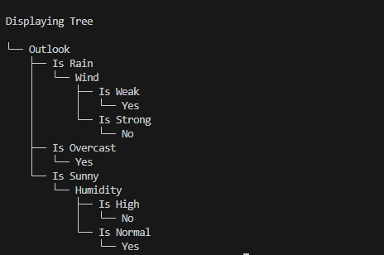

Hasil play7.csv

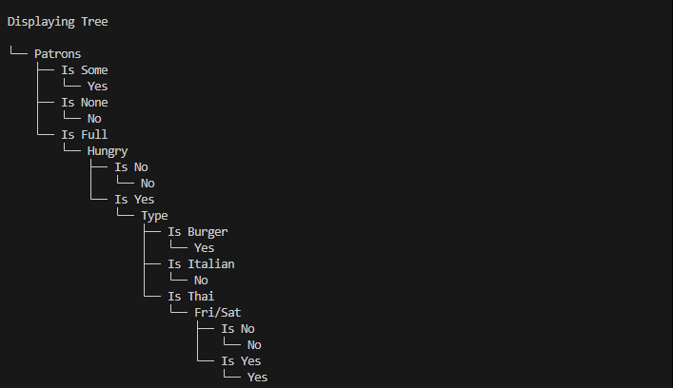

Hasil play8.csv

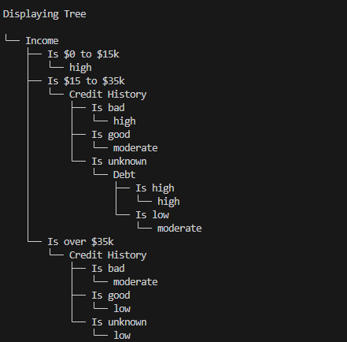

Hasil custom_play.csv

